**ANSIBLE Assignment**

**1.**Create a 3 instances

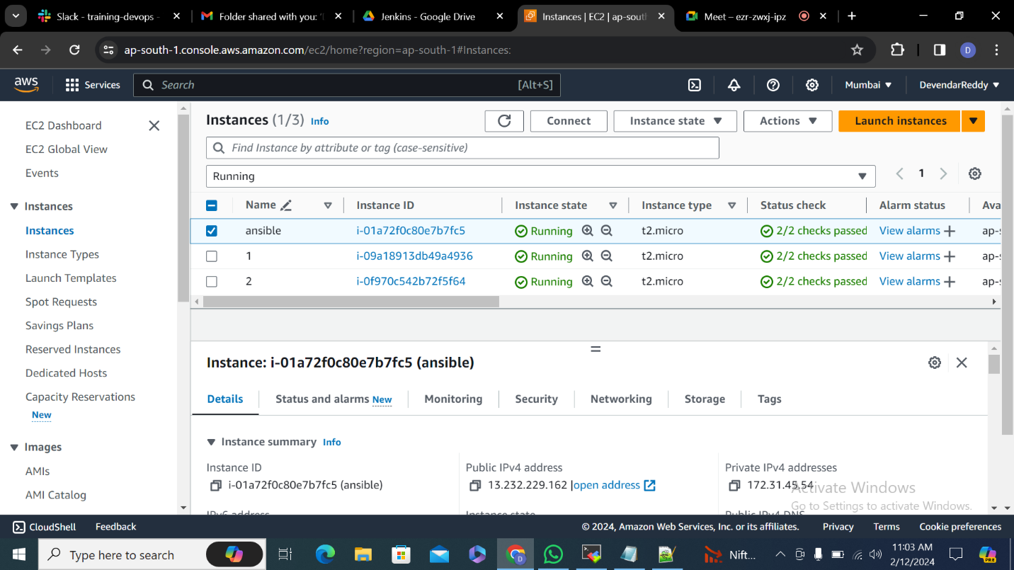

**2.**

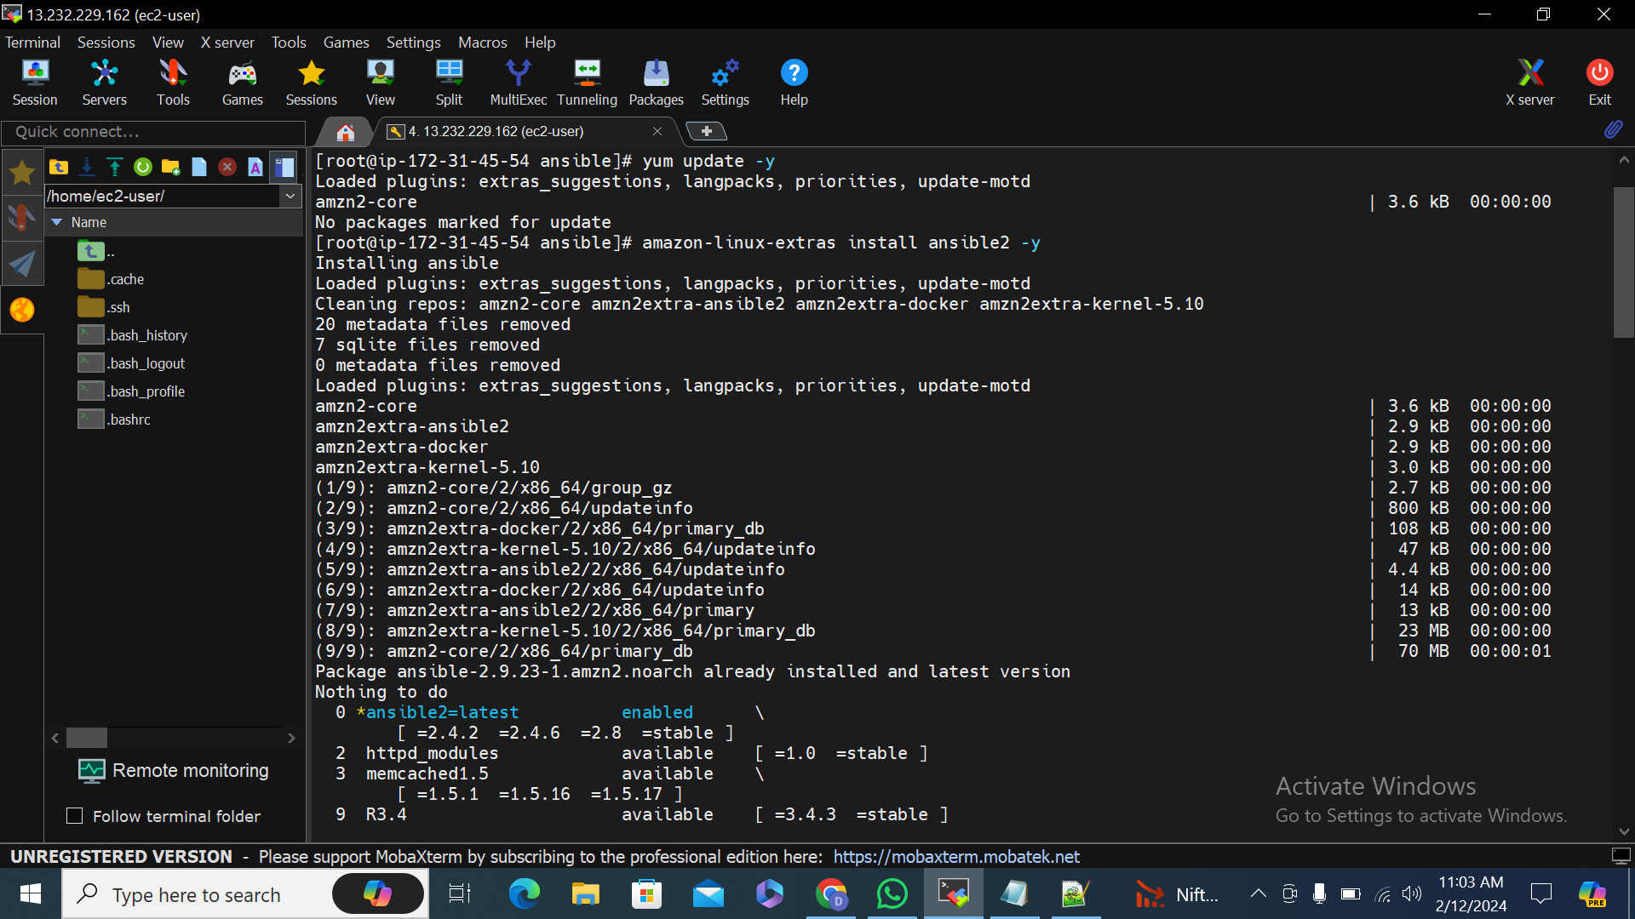

**3.**

**sudo su**

**yum update -y**

**amazon-linux-extras install ansible2 -y**

**ansible –version**

**cd /etc/ansible/**

**ls -ltr**

**vi ansible.cfg**

**#sudo user =root remove comment**

**sudo user =root**

**vi key.pem (from local copy the entaire key.pem and paste)**

**chmod 600 key.pem**

**4.**Un comment sudo user

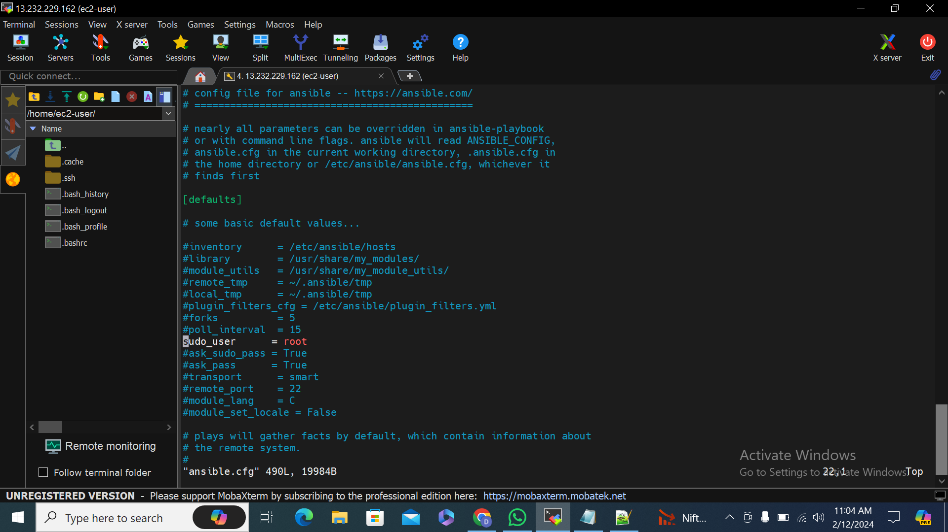

**5.**Enter public ip address in the host file

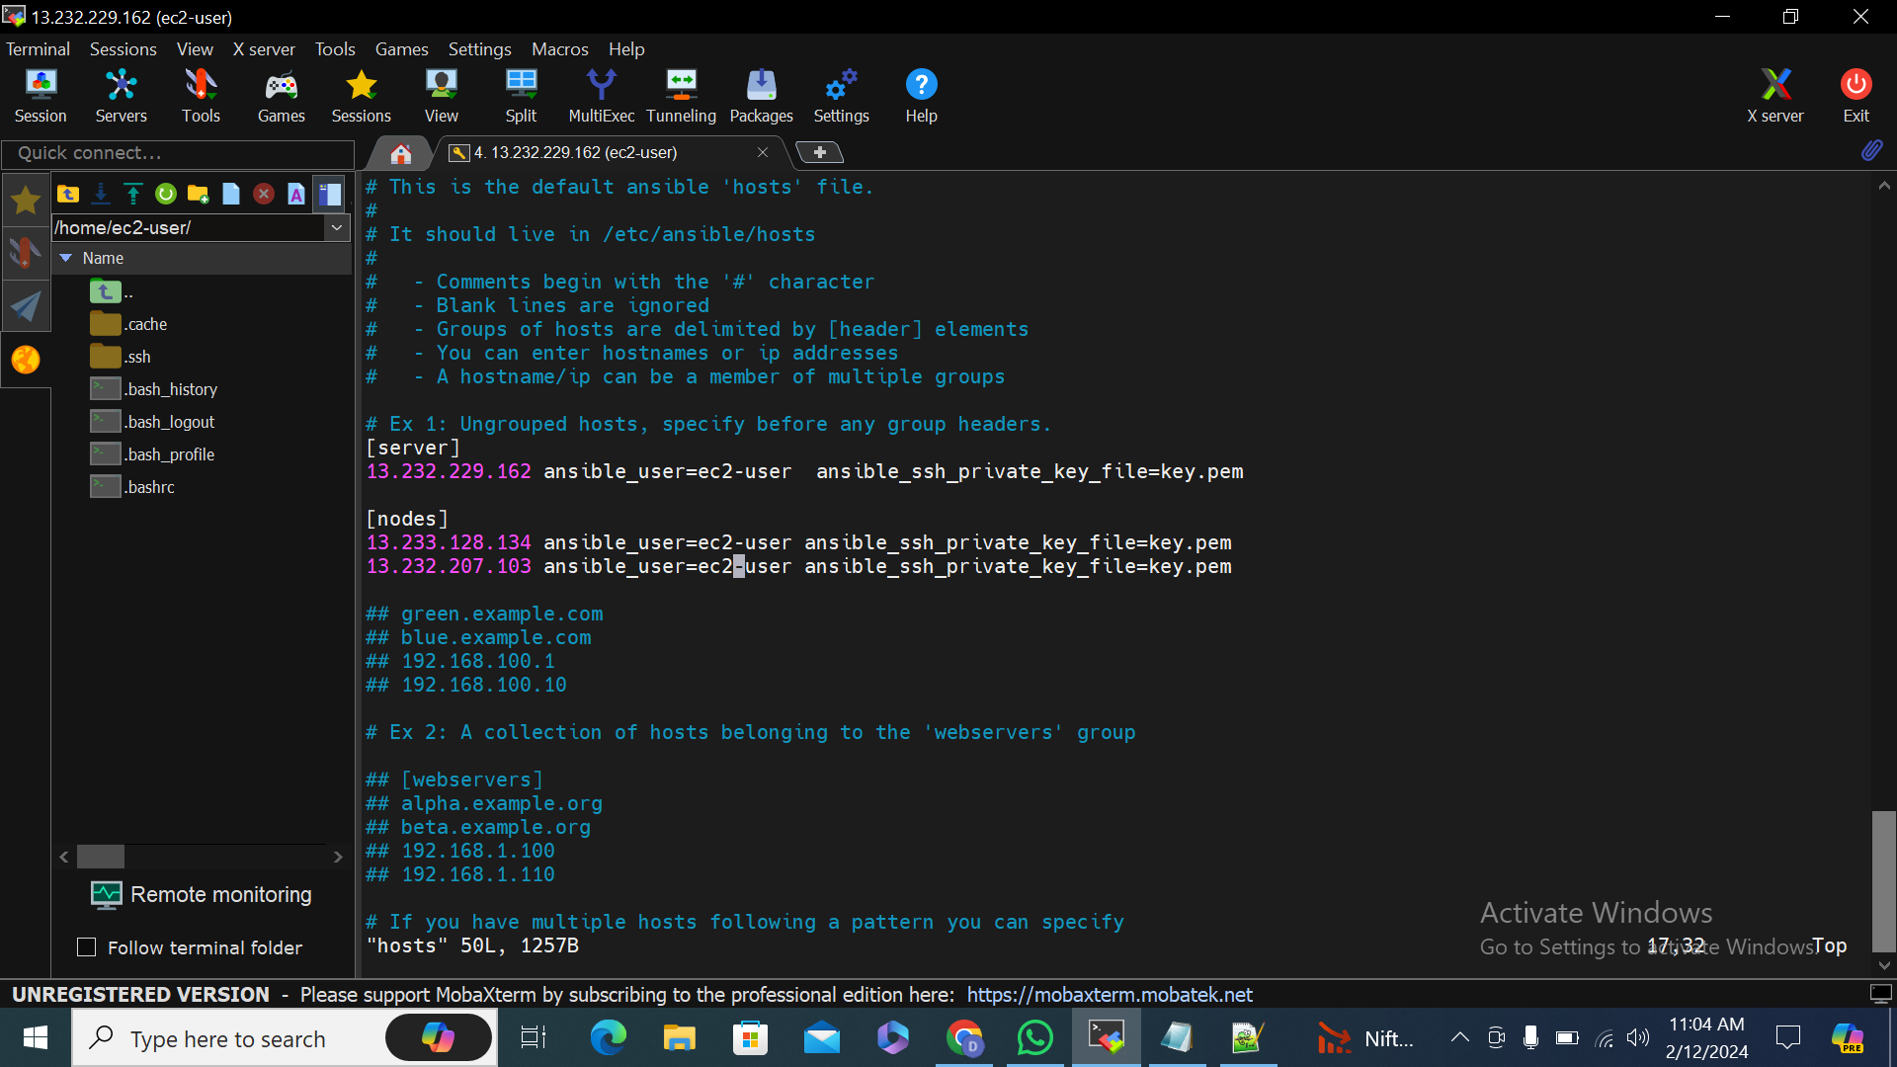

**6.**Create a own private key

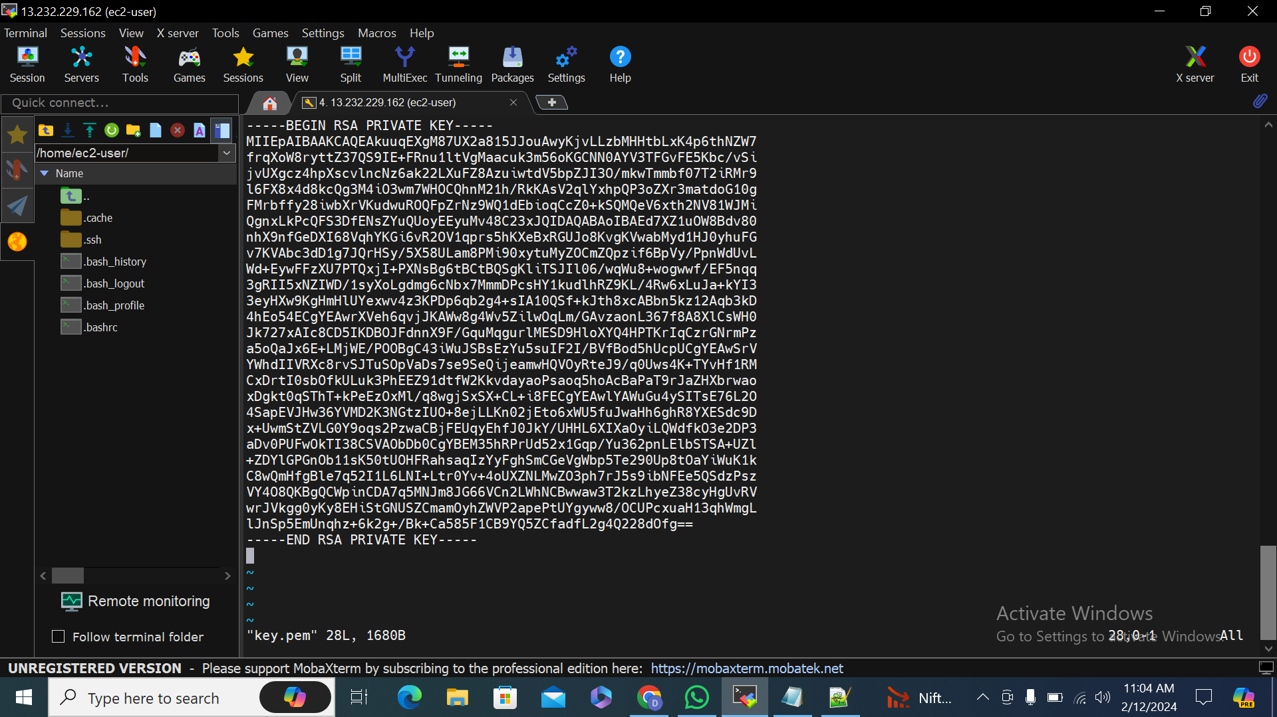

**7.**

